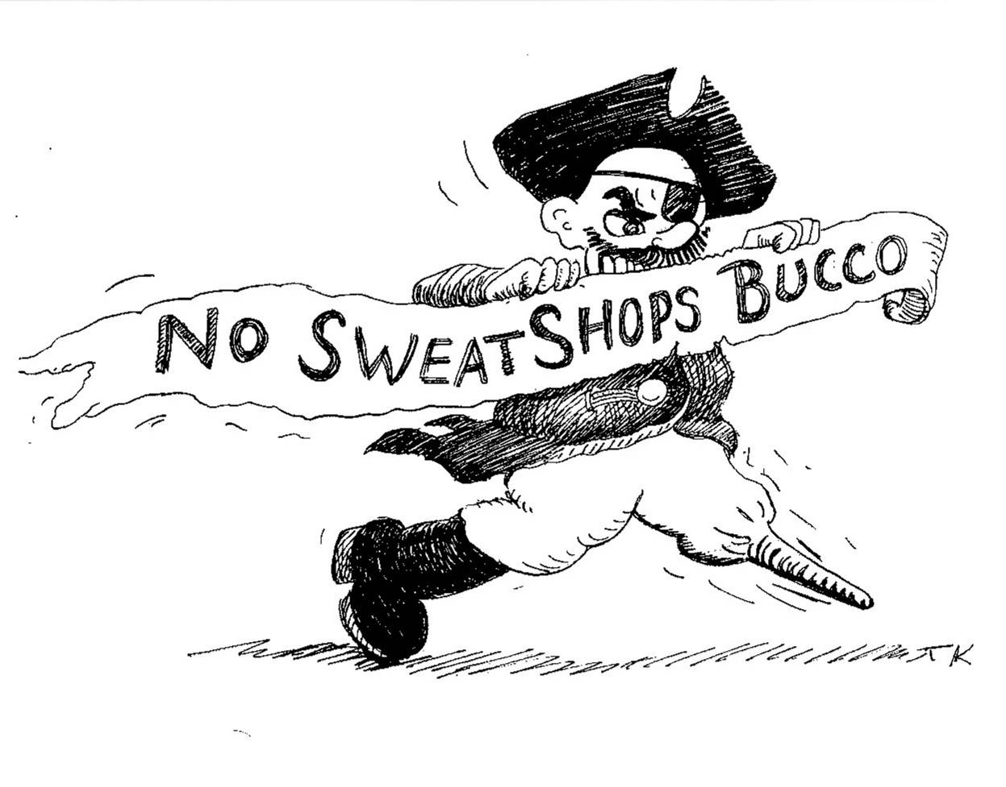
ALL STAR
2006
PNC PARK

For Immediate Release
April 17, 2006
Contact: Kenneth Miller 412-241-1339
nosweatshopsbucco@yahoo.com

“We are all caught in an inescapable network of mutuality, tied into a single garment of destiny”
Martin Luther King Jr.
January 15, 1928 – April 4, 1968

Pirates Sweatshop Baseball - Guide for Informed Reporters

The Pittsburgh Pirates Baseball Club has been “researching” the workers who sew Pirates apparel or “looking into it” or has been “unavailable for comment” for 5 years. Throughout this time they have been beneficiaries of a revenue sharing agreement with Major League Baseball (related to the licensing of the Pirates logo) and they have been directly purchasing the game day give-away products with apparent disregard for the workers who manufacture them. Patty Paytas is the team spokes person and Joe Billetdeaux is the Director of Merchandising. Both of these people have met with the Pittsburgh Anti Sweatshop Community Alliance (PASCA) and have demonstrated an understanding of international labor rights issues from the perspective of our home team.

PASCA will put credible media representatives in contact with labor union organizers or non governmental organizations in Haiti or Bangladesh who have direct experience with factory workers sewing Pittsburgh Pirates apparel.

Members of PASCA will make the time visit the Pittsburgh Pirates Gear Shop or Dick’s Sporting Goods with media representatives, collect information from the tags on Pittsburgh Pirates apparel and demonstrate simple research techniques that can be used to write informed articles about the global apparel industry and the factories where Pittsburgh Pirates apparel is sewn.

Articles about Pittsburgh Pirates sweatshops belong on the Sports Page of your newspaper along with all of the other news about the business of sports, the values in sports and sports scandals. No true fan of any sport would deny a fair playing field to the workers who sew our sports apparel.

The most important trade agreement related to major league sweatshops is the Multi Fiber Arrangement, the expiration of which amounts to the “Global Economy on Steroids.” The Multi Fiber Arrangement is the trade agreement that facilitated the exodus apparel industry jobs from the United States and has had the most profound impact on the apparel industry in the world today. It is the Multi Fiber Arrangement this is responsible for the country of origin and the “Made in **** of US and Canadian components” on so many apparel labels.

There is no confusion about what PASCA is asking of the Pittsburgh Pirates Baseball Club. We are asking that they stand up to MLB and assert same “academic standard” of sweatshop accountability as 154 colleges and universities, including Duquesne University and Carnegie Mellon. Considering the wide spread systematic violations of workers rights in the factories sewing Pirates apparel, we expect full public disclosure of factory locations, a strict code of conduct, and monitoring of factory facilities by truly independent monitors.

AFSCME Local 2459 was the sponsor of the PA AFL-CIO Resolution #87, the anti sweatshop resolution, passed at this year’s state convention at the Hilton in downtown Pittsburgh. The Pennsylvania labor movement is united in solidarity with workers in the global apparel industry.

PASCA is committed to providing the Best Major League Sweatshop Education in America at PNC Park. Members of PASCA are committed to Pittsburgh becoming a true City of Champions and demonstrating, along with the Pittsburgh Pirates, our high standards for workers’ rights during the 2006 All Star Game.

PASCA is part of SweatFree Communities, an international coalition of workers and labor rights activists focused on the global apparel industry. www.sweatfree.org

WE WILL Stop Sweatshops – July 11, 2006

